



APTECH

SFC CENTER

E-PROJECT

1st-SEMESTER

(CPISM)

AMAZING BRIDGES

PARTICIPANTS

UMER ABDUL WAHID : 1334899

MUHAMMED MAAZ : 1333600

MUHAMMAD AMMAR : 1333930

AYAN FAISAL : 1333918

|  |
| --- |
|  |
|  |
| February 19 |

­­

Table of Contents

*Acknowledgement……….…………………………….03*

*Certificate of completion……….…………………………….04*

*Introduction………...………………………………………05*

*Objectives…………………………………………………06*

*Problem statement……………………………………………07*

*Hardware/Software requirements……....................08*

*Details And Screen Shots……………………………….09*

*Summary……………………………………………….20*

# ­­­­­­­­

**ACKNOWLEDGEMENT**

*First of all we would like to thank Almighty Allah. Then we would like to thank our faculty Sir Sohail/Sir Faizan Sheikh and Sir Ali Khan for their guidance throughout the project. Our website wouldn't be the same without them as it is now. We also want to express our sincere gratitude towards E-project team from Aptech Head Office for their co-operation. At the end, we would like to express my gratitude to my friends and respondents for the support and willingness directly or indirectly to spend some time to fill in the questionnaires.*

Certificate Of Completion

Thursday

KARACHI, PAKISTAN

THE AMAZING BRIDGES

*We here by affirm to the best of our knowledge and belief, based on the observation, inspection, testing of our website and upon reports submitted by others, that this website is completely operable. Our website is completed according to instructions provided by your department.*

INTRODUCTION

*The thirst for learning, upgrading technical skills and applying the concepts in real life environment at a fast pace is what the industry demands from IT professionals today. However busy work schedules, far-flung locations, unavailability of convenient time-slots pose as major barriers when it comes to applying the concepts into realism. And hence the need to look out for alternative means of implementation in the form of laddered approach.*

*The above truly pose as constraints especially for our students too! With their busy schedules, it is indeed difficult for our students to keep up with the genuine and constant need for integrated application which can be seen live especially so in the field of IT education where technology can change on the spur of a moment. Well, technology does come to our rescue at such times!!*

*Keeping the above in mind and in tune with our constant endeavour to use Technology in our training model, we at Aptech have thought of revolutionizing the way our students learn and implement the concepts using tools themselves by providing a live and synchronous eProject learning environment!*

*So what is this eProject?*

*eProject is a step-by-step learning environment that closely simulates the classroom and Lab based learning environment into actual implementation. It is a project implementation at your fingertips!! An electronic, live juncture on the machine that allows you to*

* *Practice step by step i.e. laddered approach.*
* *Build a larger more robust application.*
* *Usage of certain utilities in applications designed by user.*
* *Single program to unified code leading to a complete application.*
* *Learn implementation of concepts in a phased manner.*
* *Enhance skills and add value.*
* *Work on real life projects.*
* *Give a real life scenario and help to create applications more complicated and useful.*
* *Mentoring through email support.*

*The students at the centre are expected to complete this eProject and send complete project along with the documentation to eProjects Team.*

Objectives of the project

*The Objective of this program is to give a sample project to work on real life projects. These applications help you build a larger more robust application.*

*The objective is not to teach you HTML/JavaScript/Dreamweaver but to provide you with a real life scenario and help you create basic applications using the tools.*

*You can revise the chapters before you start with the project.*

*This project is meant for students who have completed the module of Dreamweaver. These programs should be done in the Lab sessions with assistance of the faculty if required.*

*It is very essential that a student has a clear understanding of the subject. Students should go through the project and solve the assignments as per requirements given.*

*Kindly get back to eProjects Team in case of any doubts regarding the application or its objectives.*

Problem Statement

*Amazing Bridges website will present the information about the various famous bridges throughout the world. The information behind this creation must be added. The information of amazing bridges can be categorized based on zone wise (Longest, Tallest, Highest, Oldest etc.).*

*Requirement Specification:*

*The Web site is to be created based on the following requirements.*

1. *The Home Page should be created making use of Sections with a suitable logo, the header section can be added which will show images of famous bridges.*
2. *The site must contain the links to navigate through any category for the information.*
3. *Links of monuments can be categorized by zone wise like (Longest, Tallest, Highest, Oldest etc.) apart from country wise link can be added.*
4. *History and information of the bridges can be added along with the images.*
5. *Gallery section can be added for viewing different images.*
6. *Feedback must be allowed to enter by the viewer*
7. *Site map, Gallery, about us, Queries link, Contact us link must be added.*
8. *The complete historic reason and its description must be allowed to get download as pdf or doc file.*
9. *The advertise section of bus, flights can be included for reaching the places.*

Hardware/ Software Requirements

*Hardware*

* *A minimum computer system that will help you access all the tools in the courses is a Pentium 166 or better*
* *64 Megabytes of RAM or better*

*Software*

* *Notepad/HTML editor*
* *Dreamweaver*
* *IE 5.0/ Netscape 6.0*

# HEADER

|  |
| --- |
| We have added a Fade in slider in the header section of our home page which includes images and some description of the most famous bridges of the World. CODING: |
|  |
| CATEGORIES We have divided all famous bridges into categories like longest, highest and oldest. Then we created separate page of every category through which you can easily select the bridge, you want to know about.  CODING: |

QUERIES

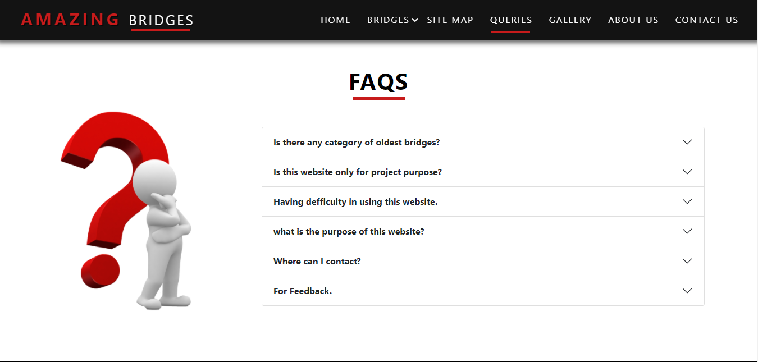We have added a page of Queries which shows all Frequently Asked Questions.

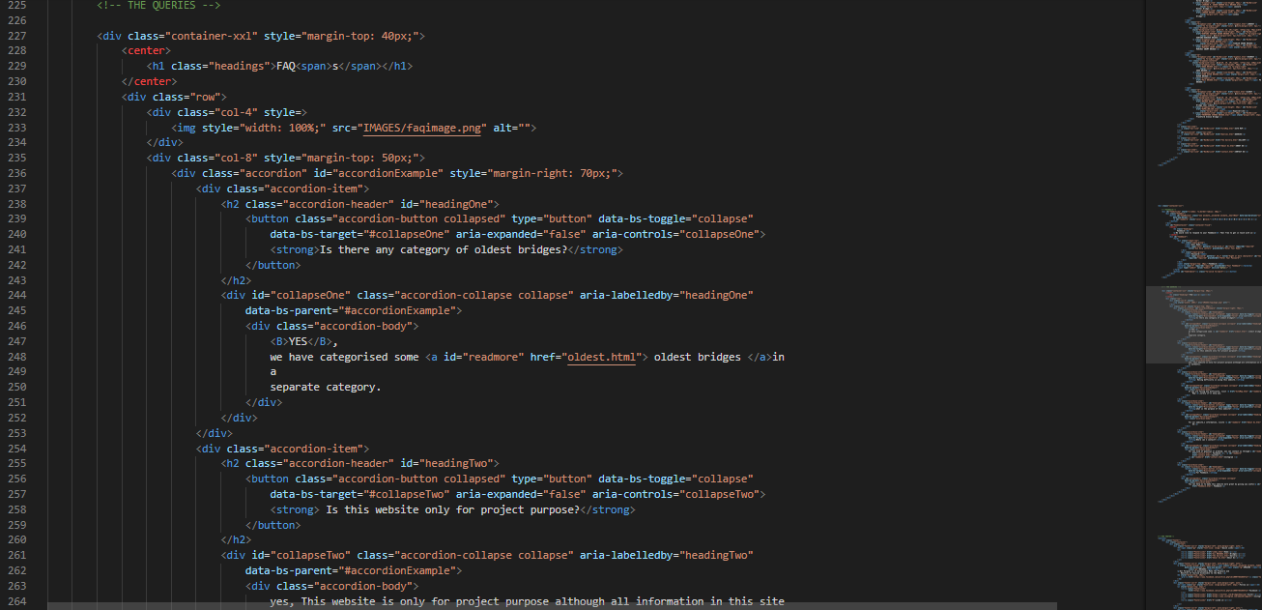CODING:

CONTACT US

We have added a page named Contact Us, from where you can ask any question or any queries easily.

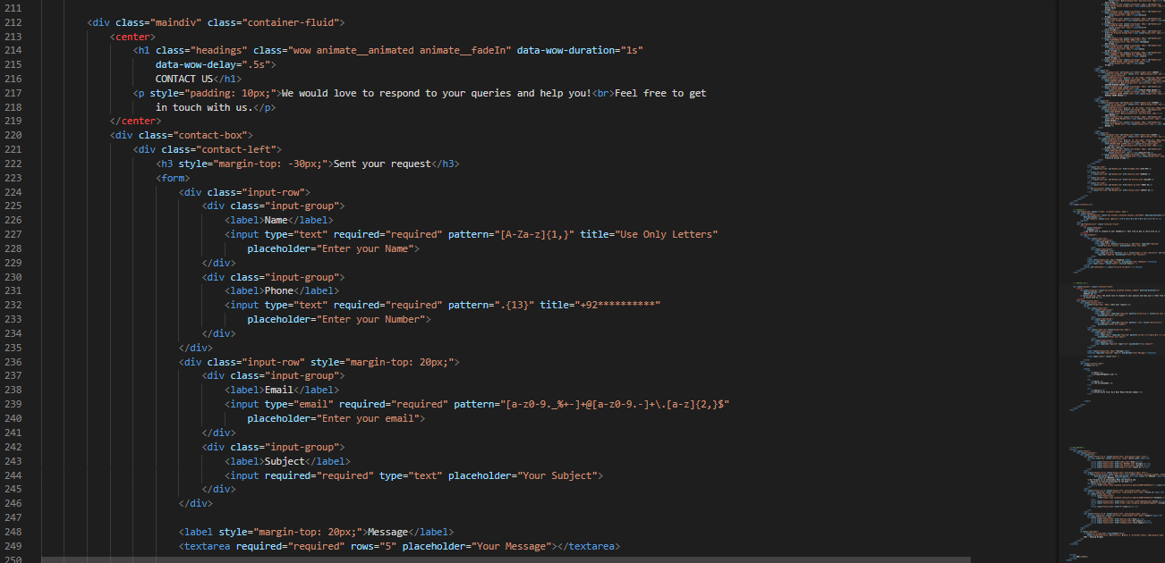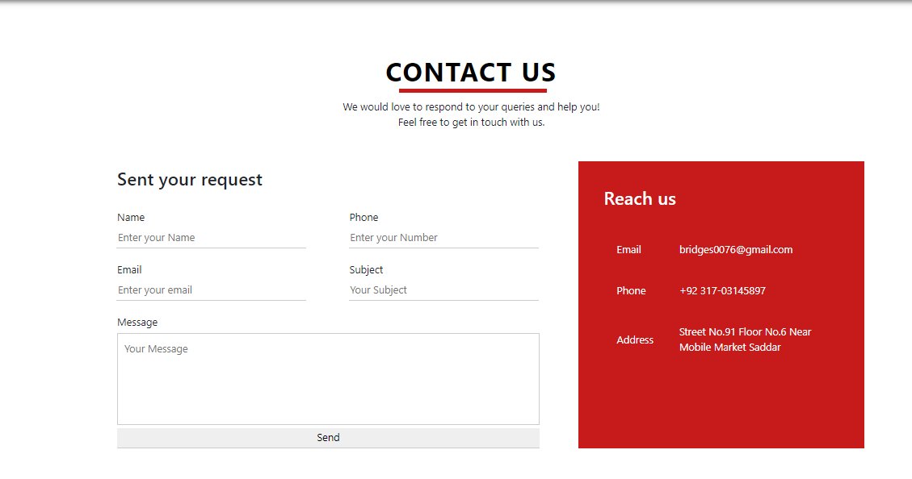CODING:

ABOUT US

We have added information behind this website and about our company in a separate page named About Us.

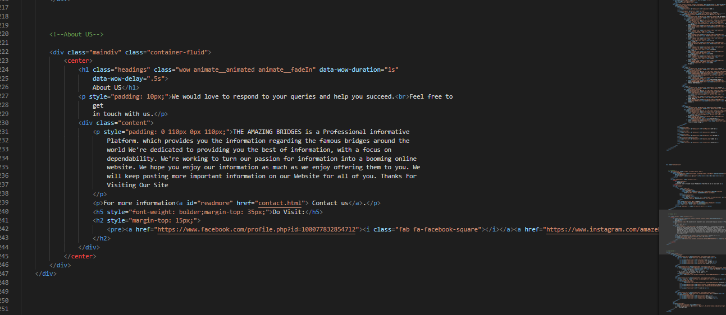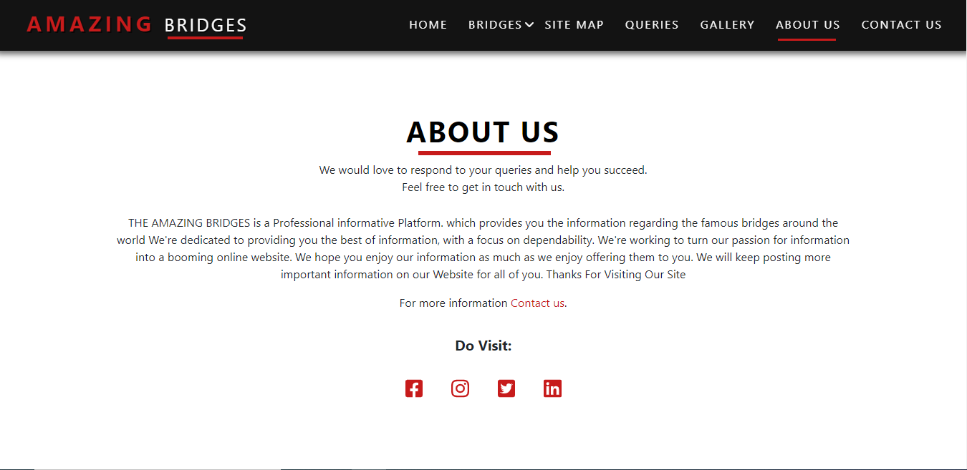CODING:

SITE MAP

We have made a Site Map of our website as instructed. This Map shows the structure of our website.

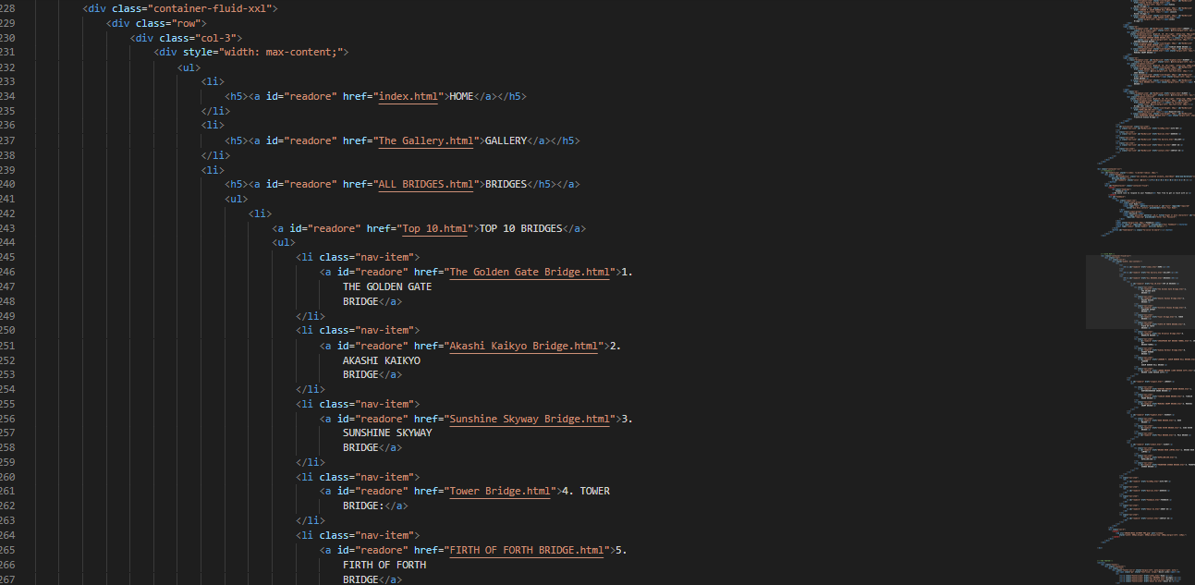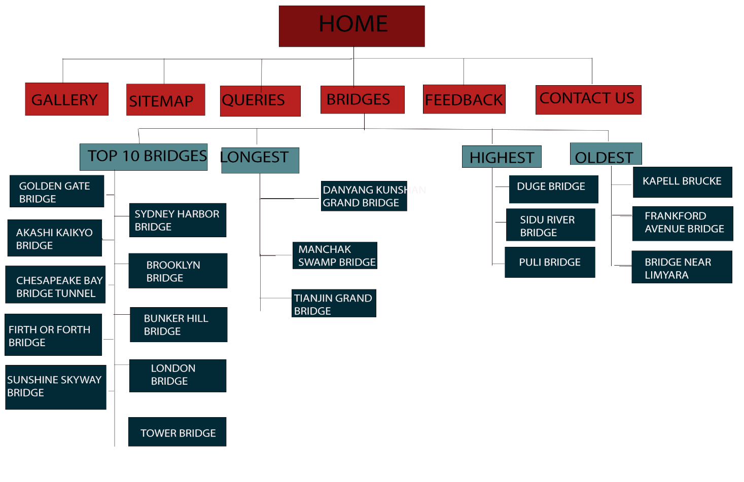CODING:

FEEDBACK

We have added a feedback button through which you can send your feedback and help us to improve our mistakes.

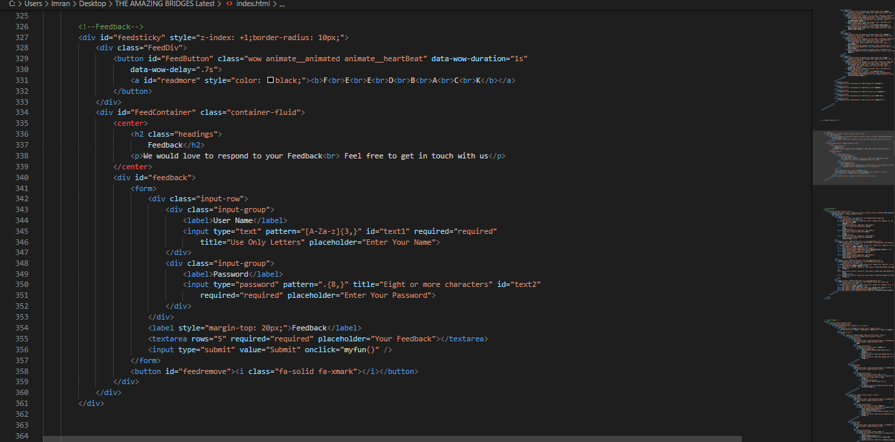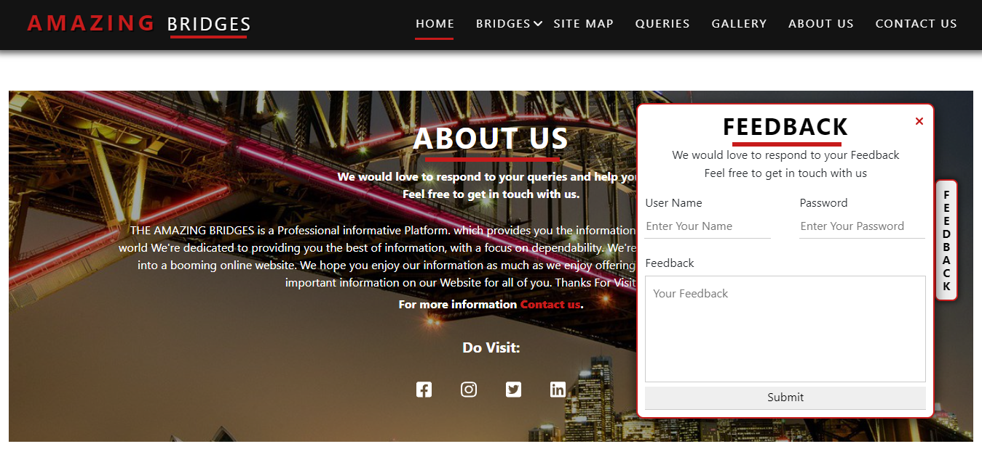CODING:

GALLERY

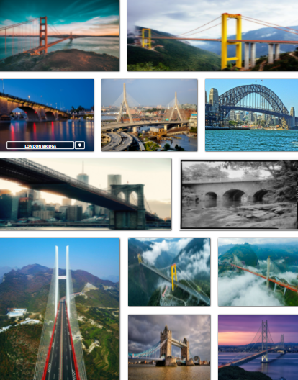We have added a Gallery, which shows images of all bridges. We have given a location button on every image through which you can see the bridge on Google Map.

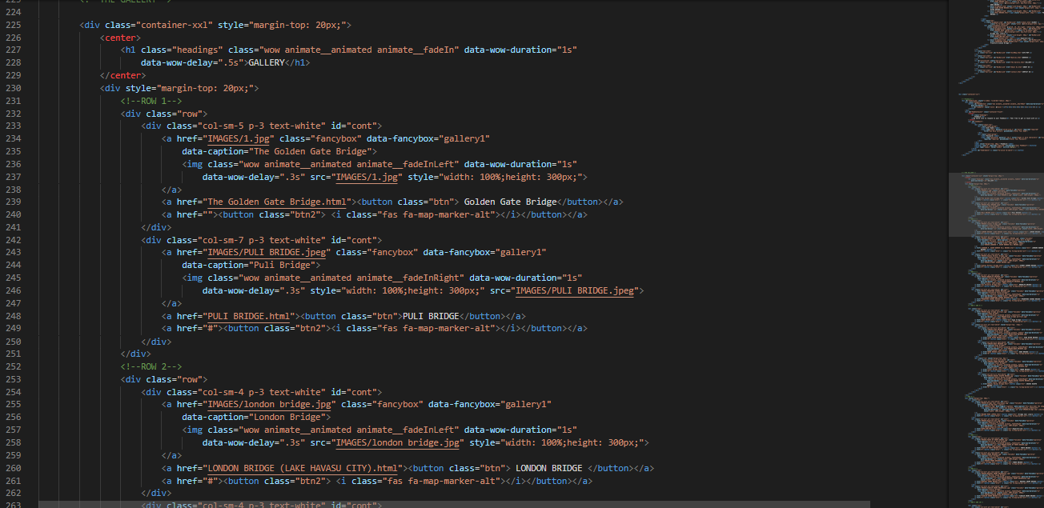CODING:

COUNTRIES BANNER

We have added a country banner in our home page which show countries which are famous for their bridges. You can also visit the bridges of those countries through this banner.

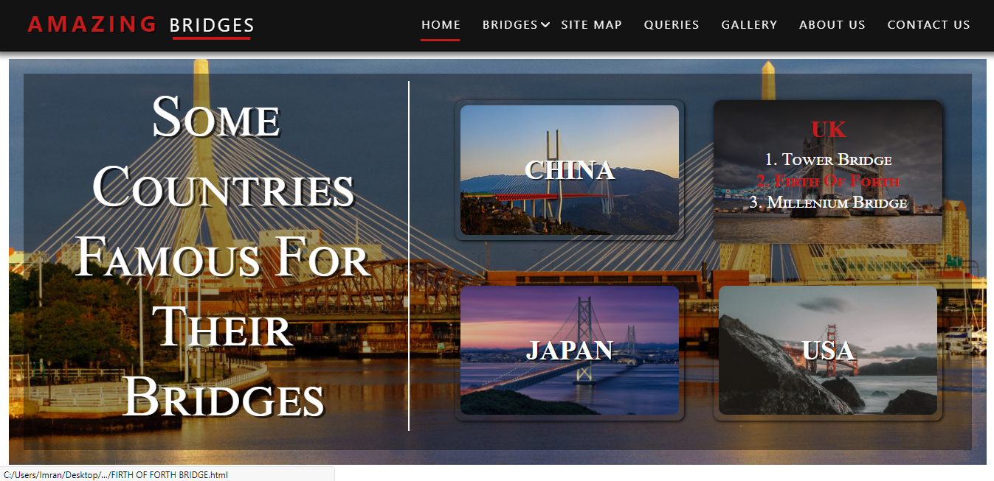

CODING:

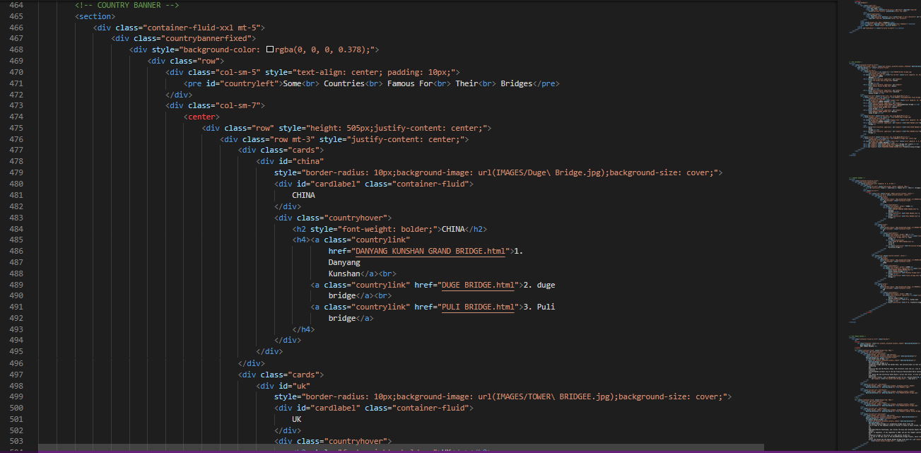

ADVERTISEMENT

We have added an advertisement section in which we have give a sample ad of some Airline company.



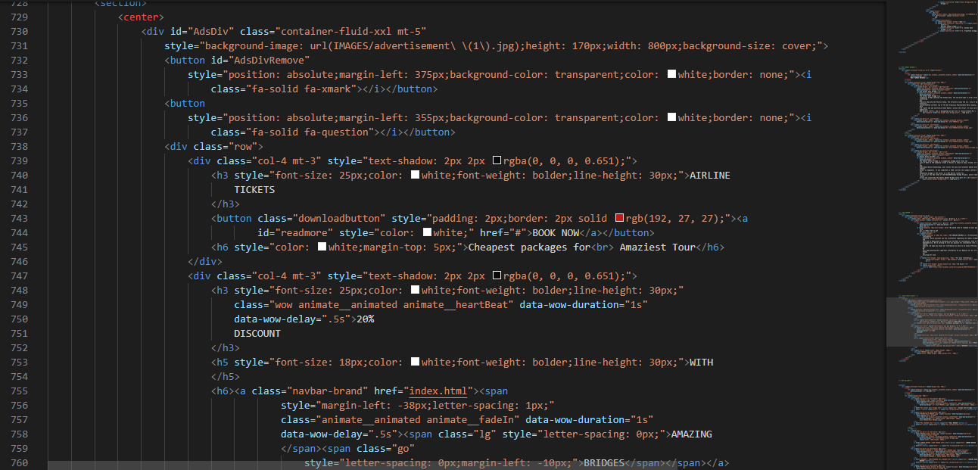CODING:

FOOTER

The Footer of our website includes quick links and social media buttons. We have given support links too.

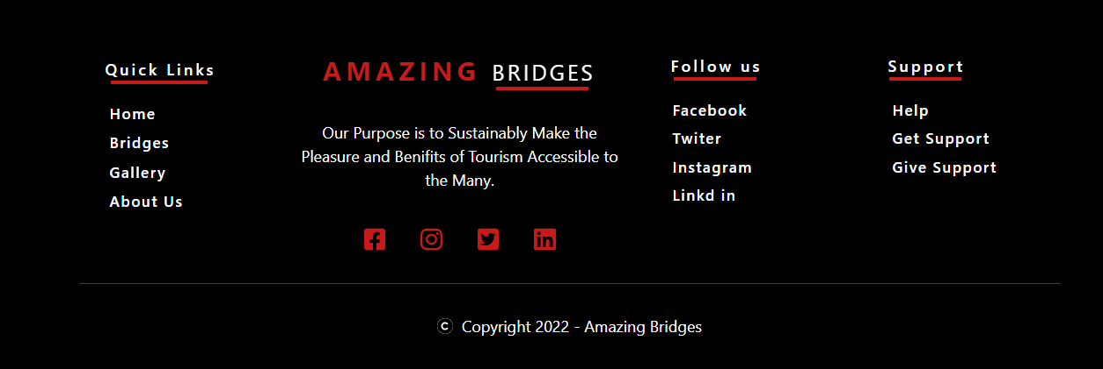

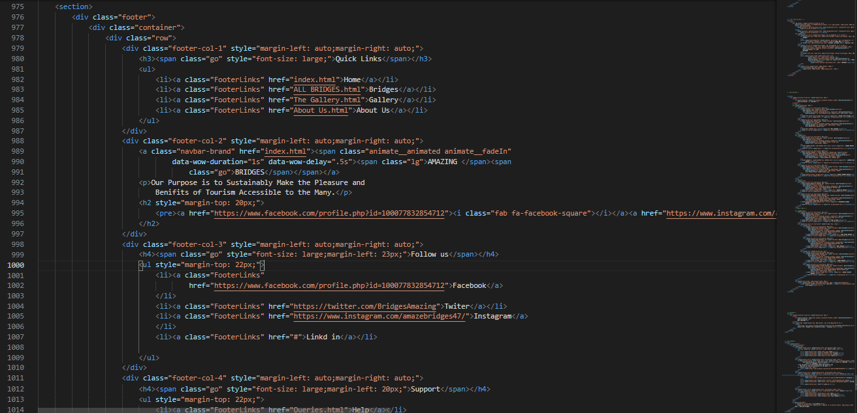CODING:

SUMMARY

By the grace of Almighty ALLAH we have completed our project. We would like to thank our faculty Sir Sohail, Sir Faizan Sheikh & Sir Ali Khan for their guidance and support throughout the project. These are the following things that we have included in our website

* A nav bar that includes different links which has been connected to the different pages on the website.
* A top 10 page which includes the complete information of the top 10 bridges around the world.
* 3 more different pages which includes highest, oldest & longest bridges with their complete information.
* We have added a country banner in our home page which show countries which are famous for their bridges. You can also visit the bridges of those countries through this banner.
* An about us page where we have added the information about our website.
* We have added an advertisement section in which we have give a sample ad of some Airline company.
* A feedback page which includes a feedback form through which a user can tell us about his experience.
* A query page which includes FAQS
* We have made a Site Map of our website as instructed. This Map shows the structure of our website.
* We have added a Gallery, which shows images of all bridges. We have given a location button on every image through which you can see the bridge on Google Map.
* The Footer of our website includes quick links and social media buttons. We have given support links too.